**My name is ……………** *English Homework*

*My pencil case*

*…… /……/……*

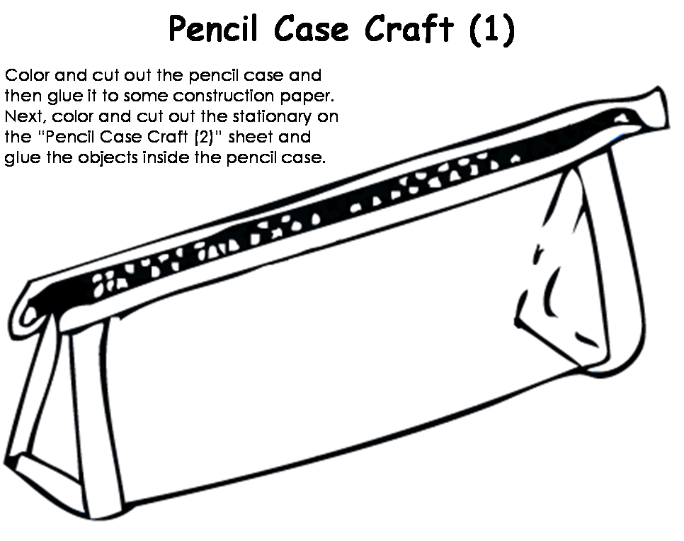- - - - - - - - - - - - - - - - - - - - - - - - - - - - - - - - -

**Cut out, stick and colour ☺**

